REDCap logo 

COVID Employee Exposure Tracking

**Closing an Investigation**

**FIRST DEACTIVATE THE EXPOSURE EVENT**

1. Click **Add/Deactivate an Exposure Event** 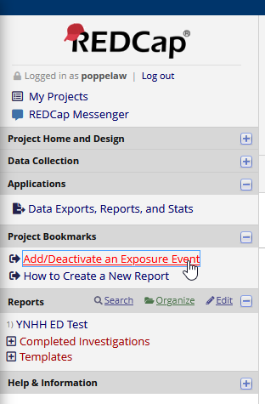
2. Select **Deactivate an existing event** and select the event you’d like to close from the dropdown. **Click Submit.**

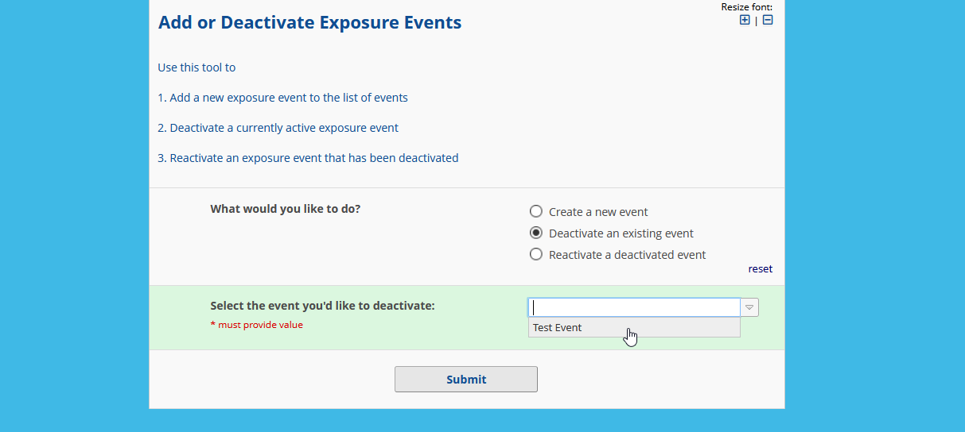

**THEN DEACTIVATE THE EVENT’S REPORT**

1. Click Organize in the **Reports** section of the project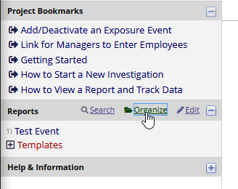
2. Select Completed Investigations in the **Select a folder** dropdown

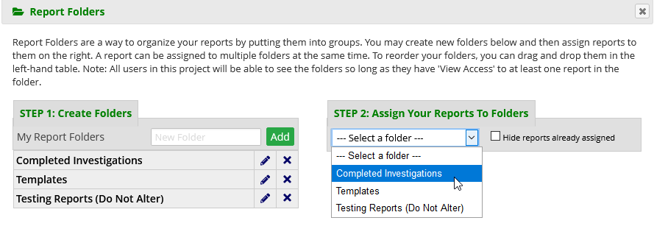

1. Find the report you want to deactivate and check the box.

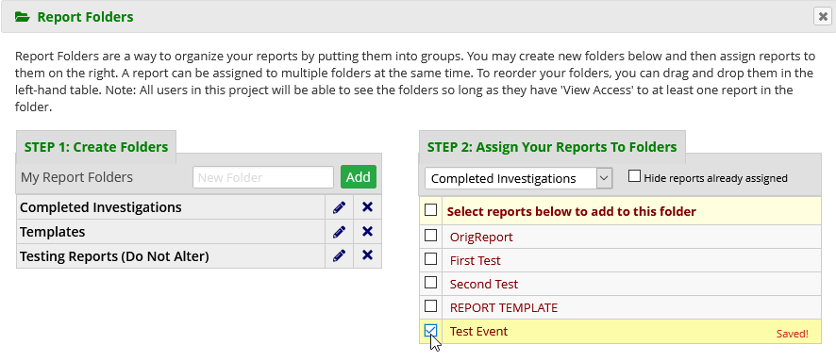

1. Click **Close** and you’re done!

